**Installing Support Package for RTL-SDR**

* Open MatLab, if you do not already have an account register with Mathworks via following this link [https://uk.mathworks.com/mwaccount/register?](https://uk.mathworks.com/mwaccount/register?uri=https%3A%2F%2Fuk.mathworks.com%2Fproducts%2Fget-matlab.html%3Fs_tid%3Dgn_getml)
* On the Home ribbon on the “Add-Ons” button and select “Get Hardware Support Packages”

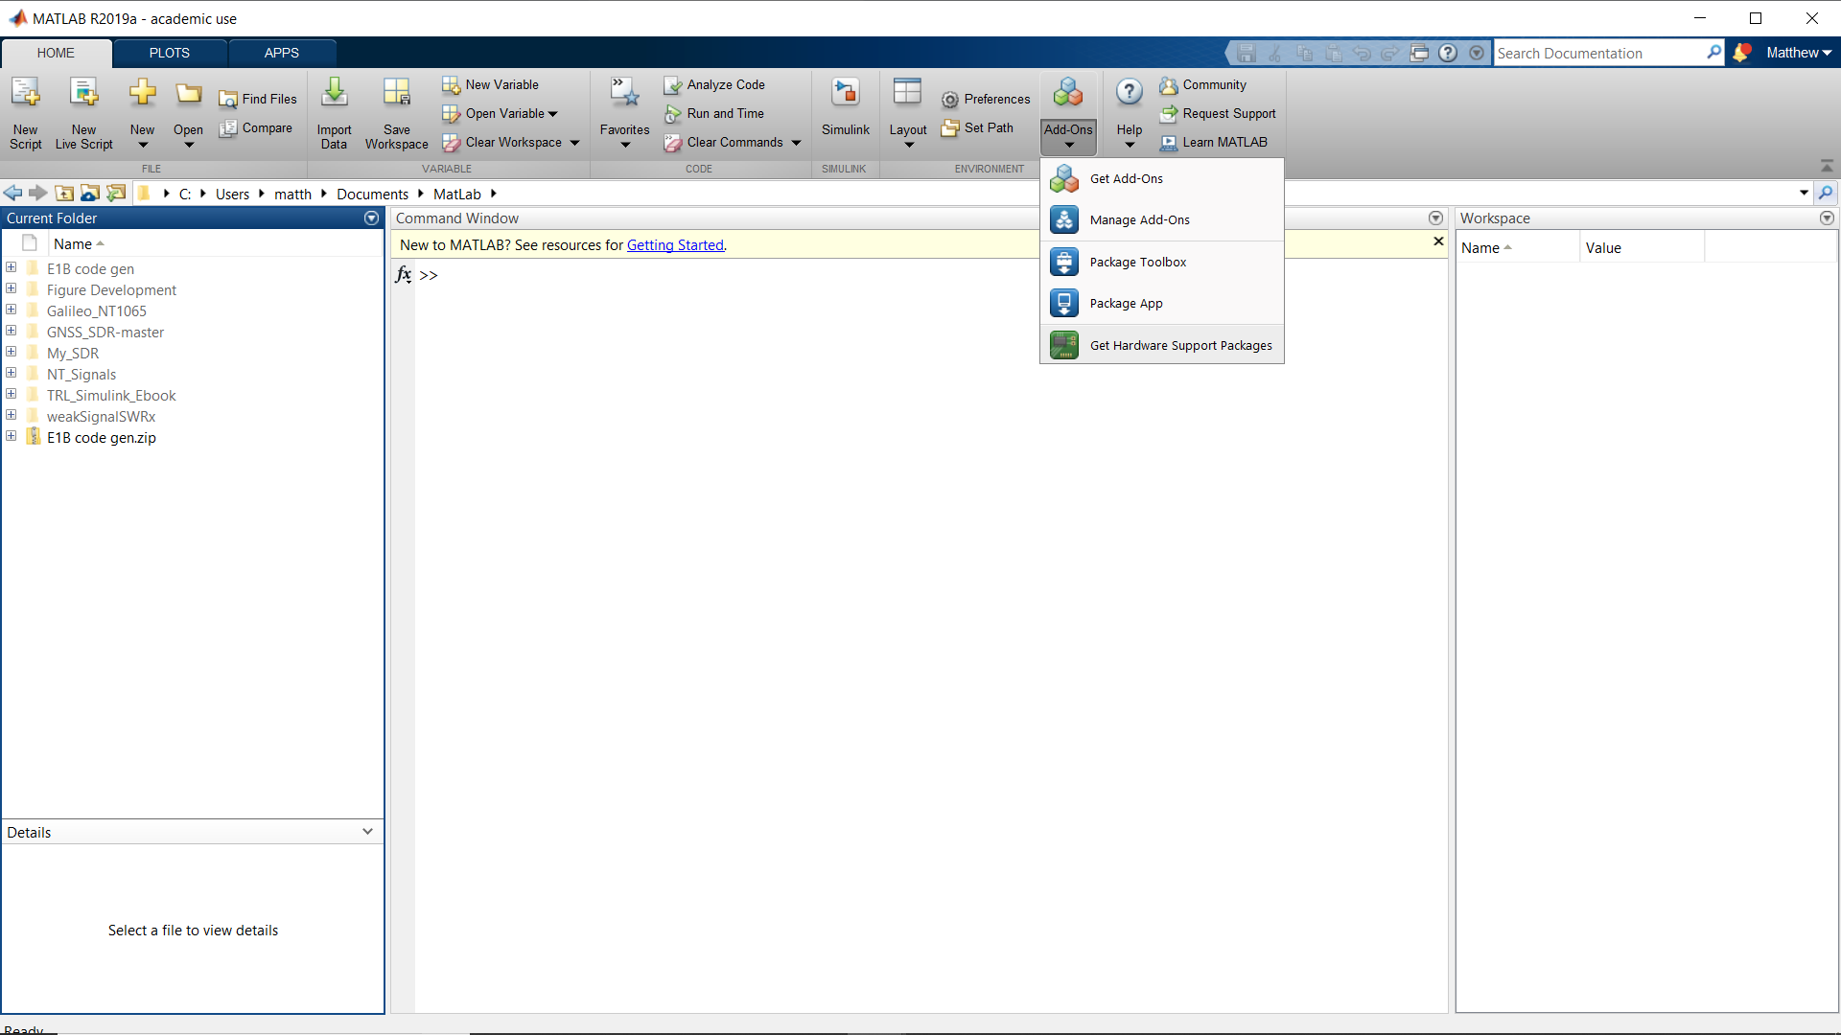

* Select the Communications Toolbox: Support Package for RTL-SDR
* Select Install and a new window should open. Agree to the Terms and Conditions and follow the instructions to complete installation.
* Configure the Hardware Support Package by selecting “Setup Now” on the Installation Complete Page.
* Do not click on the “install driver” button in the zadig window until instructed to do so in the MatLab window. Click through the instructions to ensure the correct driver for the RTL-SDR is installed.
* Test your radio connection, if installed correctly the radio name and other information will be displayed as seen below:

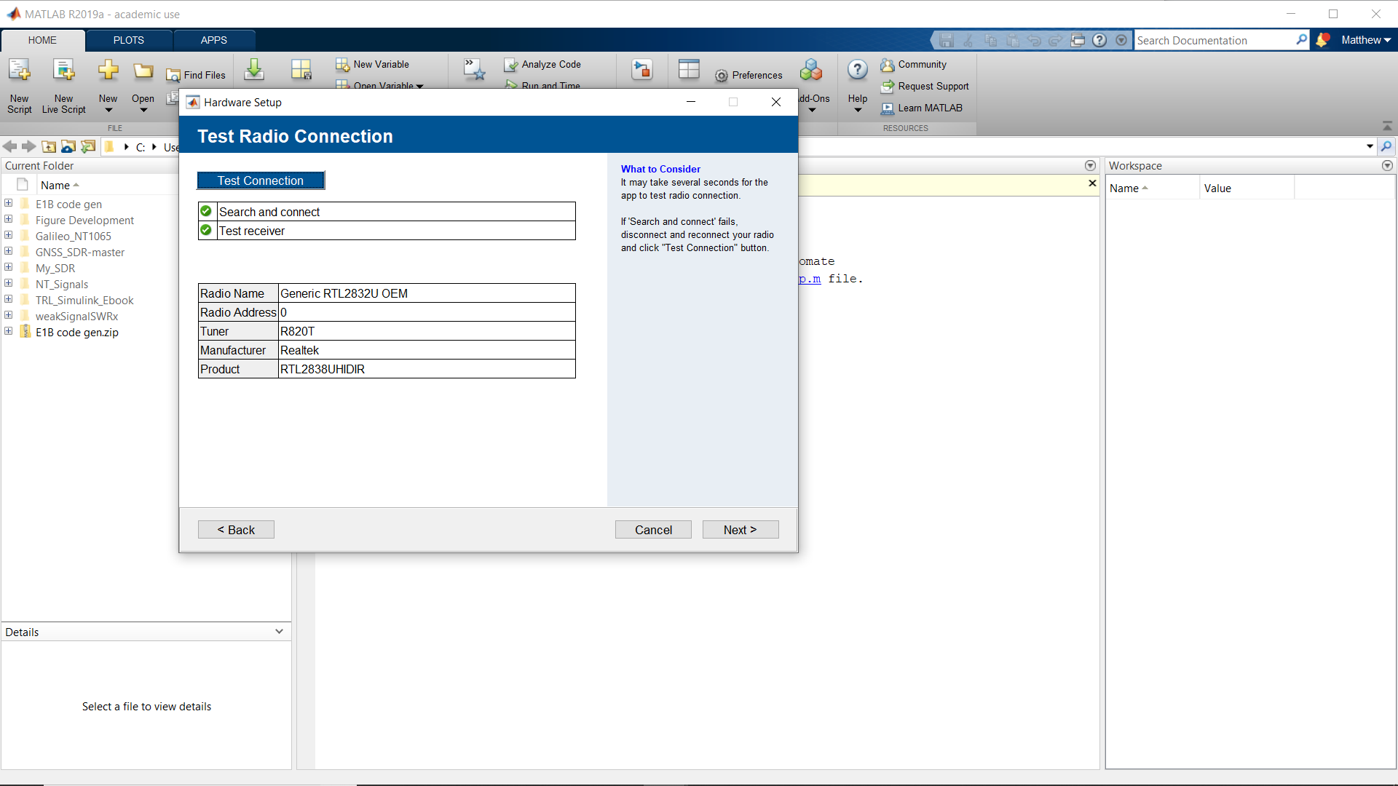

* The radio connection can be tested at any time in the MatLab command window by typing:

my_rtlsdr = sdrinfo

* Add the custom Simulink library (necessary for recording GNSS signals) to MatLab by selecting the “Set Path” button on the Home ribbon and then select “Add Folder” and navigate to the rtlsdr_book_library. Select the folder and save the changes.

